Swagger UI tutorial

1. Once the Brain.API.Console application is running, go to <http://localhost:1234/swagger-ui/>

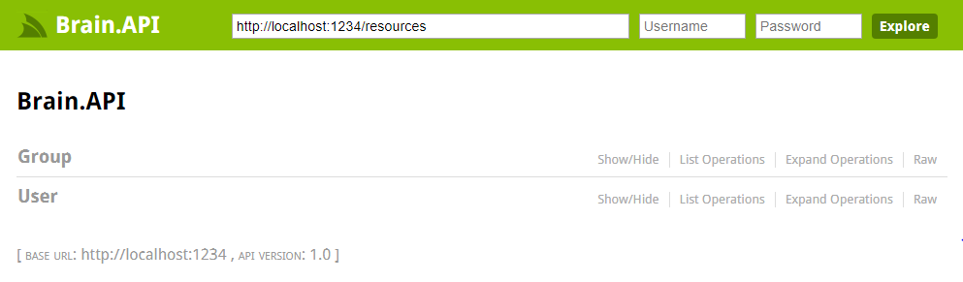

1. Select the desired route

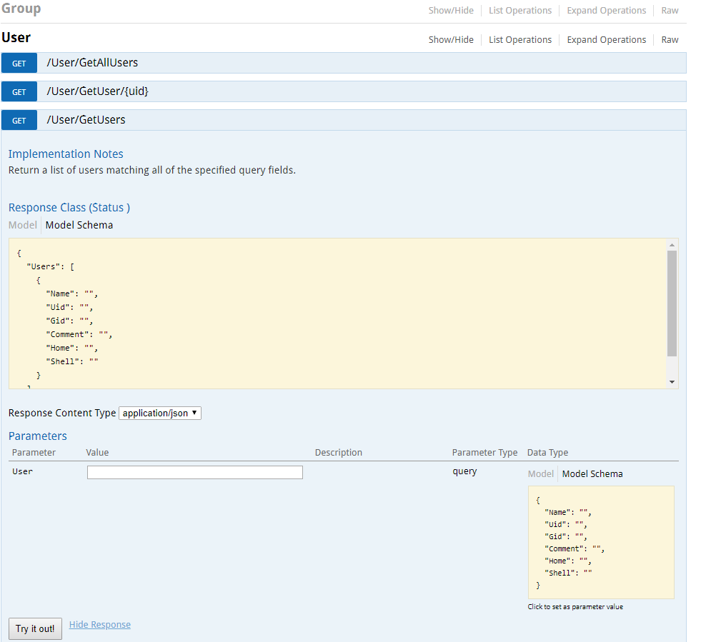

1. Enter the parameter for the route and click ‘Try it out!’. Example of parameters:

* GET /User/GetUser/{uid}: 1
* GET /User/GetUsers: {Name:adib}, {Name:adib,Uid:12345,Gid:1002}
* GET /Group/GetGroup/{gid}: 1001
* GET /Group/GetGroups: {Name:devops,Gid:1234,Members:[adib,eugene]}
* GET /Group/GetGroups/{uid}: 1

1. The output will be displayed in the Response Body window.

